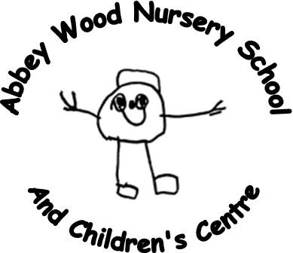
Abbey Wood Nursery School & Children’s Centre
Dahlia Road, Abbey Wood, London SE2 0SX
Headteacher: Ms Clare Barber
Tel: 0208 311 0619 Fax: 0208 312 0319
Email: headteacher@abbeywood-nur.greenwich.sch.uk

Application for Admission

Date
First Name |  |  | Surname
Date of Birth |  |  | Boy/Girl
Full name of parent(s) or adult(s) with whom child lives:

……………………………………………………………………………………..Relationship to Child:…………………………………………

……………………………………………………………………………………….Relationship to Child:……………………………………….
Home Address:

Post Code:
Home Telephone Number: |  | Mobile Telephone Number: |  | Work Telephone Number:
Full name and address of parent if separated:

Childminder’s Address (please supply photocopy of contract with application):

GP/Health Visitor:

2½ year check? Yes………. No……….

Special Needs (e.g developmental delay, speech delay, medical condition)

Need for Place (e.g. poor accommodation, lack of garden, child care difficulties)

Is there any other information you would like to share with us?

OTHER CHILDREN IN FAMILY
Name |  | D.O.B |  | School
Name |  | D.O.B |  | School
Name |  | D.O.B |  | School
Name |  | D.O.B |  | School
Name |  | D.O.B |  | School

Please Tick Ethnicity
Black African  Ghanaian/Nigeria |  | Black Caribbean |  | Other Black |  | White English/  Scottish/Welsh
White Irish |  | White European |  | Other White |  | Bangladeshi
Chinese |  | Indian |  | Pakistani |  | Vietnamese
Other Asian |  | Turkish/Turkish Cypriot |  | Other |  | Mixed Origin

Home Religion
Language(s) spoken at home
Has the family refugee status
Are you working full time?
Are you working part time?
Are you in further education? | Full Time ………. Part Time ……….

General Information
Eligibility criteria for pupil benefits
Do you claim Employment and Support Allowance (Income Related)
Income Support
Income Based Job Seekers Allowance
Child Tax Credit (NOT Working Tax Credit) and annual income below the relevant threshold

Any other agencies involved with your family?

Name of Intended Primary School:

How would you travel to the Centre (please circle)

Walk Car Bus Train Cycle
How did you hear about the Centre?

I agree that the school can contact to request information from any other service who may be involved.

Signed…………………………………………………………………………….Date……………………………………………

